Sistemas Informáticos (Computer Systems)
Unit 08. Computer assembly and repair. Assembly - Part 1



Authors: Sergi García, Alfredo Oltra
Updated January 2023
Licencia
Reconocimiento - No comercial - CompartirIgual (BY-NC-SA): No se permite un uso comercial de la obra original ni de las posibles obras derivadas, la distribución de las cuales se ha de hacer con una licencia igual a la que regula la obra original.

Nomenclatura
A lo largo de este tema se utilizarán diferentes símbolos para distinguir elementos importantes dentro del contenido. Estos símbolos son:

📖 Important

❕ Attention

💬 Interesting
INDEX
1. Introduction 3
2. Security measures 3
3. Assembling a computer. Step 0 – Procuring parts and tools 3
3.1 Simulators 3
3.2 Visual guides 3
3.3 Video guides 4
4. Assembling a computer. Step 1 – Procuring parts and tools 4
5. Assembling a computer. Step 2 – Motherboard, processor and ram memory 4
6. Assembling a computer. Step 3 – Install power supply and motherboard in the case 5
7. Assembling a computer. Step 4 – Inserting expansion cards 6
8. Assembling a computer. Step 5 – Connecting Hard disk, DVD and other SATA components 6
9. Assembling a computer. Step 6 – Closing the case and connecting external peripherals 7
10. Bibliography 7

Unit 08. Computer assembly and repair. Assembly - Part 1

Introduction
In this unit, we are going to learn the most common steps to assemble a computer from scratch. Also, we are going to learn basic security measures to manipulate computers.
This part is a guide for the process, but to understand the process is mandatory to watch video guides, video tutorials and simulators whose links we have provided.

📖 Important: If you can, you can test it assembling a real computer, but if you do it in is mandatory to follow strictly the security measures to avoid danger.

Security measures
Firstly, we have to know the main security measures to take when we are manipulating electrical devices (such a computer). It’s very important to take those security measures for two reasons: our security and to avoid breaking components.

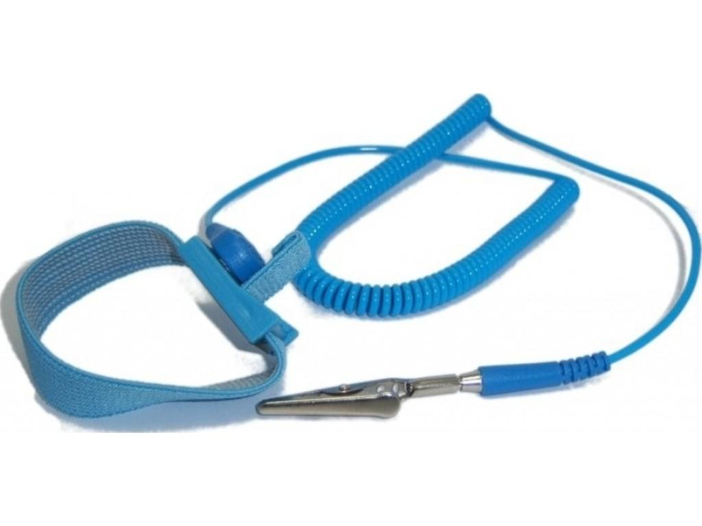
- Risk of electrical shock: when you manipulate a computer, it must be disconnected from any power source (including batteries if it is a laptop) to avoid risk of electrical shock. Several components like power supply are specially dangerous, and it should not be opened and manipulated if you don’t know what you are doing.
- Electrostatic charges: we can accumulate little electrostatic charges in our body. It isn’t a problem for us, but they can damage electronic components. To avoid this problem you can use an anti-static wristband, or it isn’t available, simply touch a metallic case that is in contact with ground to discharge.
- Sharped edges: be careful, computer components had a lot of sharped edges, and you could get hurt.
- Liquids: liquids like water can damage electronic components. If a component get wet, you have to wait to get completely dry before connecting it to any power source.

Assembling a computer. Step 0 – Procuring parts and tools
This document is a text guide of the main steps to assemble a computer. The process of assembling a computer is very visual. This text is only to support you, we recommend you to watch videos and try simulators like:

Simulators
There is a Cisco tools called IT Essentials Virtual Desktop (Flash Player is required). Also, there are commercial games like “PC Building Simulator 1 and 2”, available in “Epic Store” in this URL
https://store.epicgames.com/es-ES/p/pc-building-simulator

Visual guides
- Tom's Hardware
- Instructables
- Wikibooks

Video guides
- Computer Assembly and Disassembly
- How to assemble your own PC. Tagalog
- How to build a PC: A step-by-step guide

Assembling a computer. Step 1 – Procuring parts and tools
The first step to take is procuring all computer components (Motherboard, RAM, Processor, Fan, Hard disk, DVD, …) .
❕ Attention: before start to assemble your computer, you should check all computer components are compatible. If a component isn’t compatible, the computer will not work, or even it could damage other components.
Also, you have to procure required tools (screwdriver, container to hold screws, heat sink compound, a little flashlight, ….).
📖 Important: check first that you have to use right tools for each task. Using tools that doesn’t fit the task (for example, using a knife as a screwdriver) could cause bodily injury or damage computer components.

Assembling a computer. Step 2 – Motherboard, processor and ram memory
In this step, we are going to insert the processor and RAM memory on the motherboard.
This step could be done with the motherboard in the case, but it is easier to do if the motherboard is outside the case because we have more space to manipulate components.
The components in this step are:
- Motherboard.
- Processor.
- Heat sink compound.
- Cooler (usually composed by and heat sink and a fan).
The steps are:
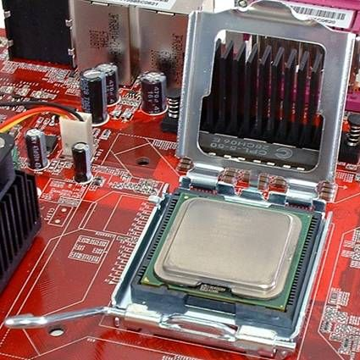
- Insert the processor in the socket. Be careful, it only works in one position.
Use the Zero Insertion Force engine to set the processor in the motherboard.
Apply the heat sink on the processor. One of the most used techniques is to draw an X on the processor and when you put the cooler it will be expanded. About heat sink compound.

❕ Attention: it is mandatory to use a heat sink. It creates a layer to conduct heat to the cooler. Without a heat sink, the cooler can’t take the heat of the processor, and it can be damaged.
- Insert the cooler on the processor (insert the sink on the heat sink and the fan on the sink) and connect its fan to the motherboard.
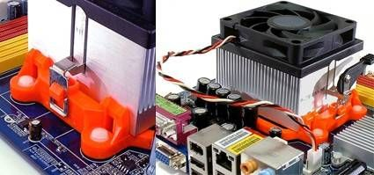
- Insert RAM memory in the RAM Socket.
❕ Attention: RAM sockets are asymmetric, check it before insert.

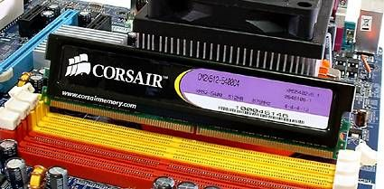

Assembling a computer. Step 3 – Install power supply and motherboard in the case
In this step, we are going to install the power supply and the motherboard in the case.
- First of all, we have to put the power supply in the case and screw it.
- Secondly, we have to put the motherboard in a case that supports its form factor and screw it.
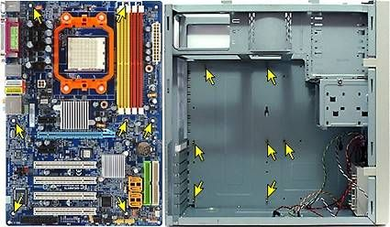
- Thirdly, there are connectors in the case (Power button, reset button, HD LED, etc…) that you have to connect to the motherboard. To determine where they go, you have to check the motherboard manual.
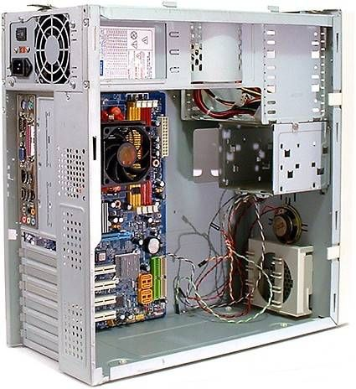
Lastly, we can connect a power supply to the motherboard.
💬 Interesting If the case is small, or simply we need more space to feel us comfortable, we can do this step as last step of all the process, saving space to manipulate other components.

Assembling a computer. Step 4 – Inserting expansion cards
In this step we are going to insert expansion cards (graphic card, Ethernet card, port expansion card, ….).
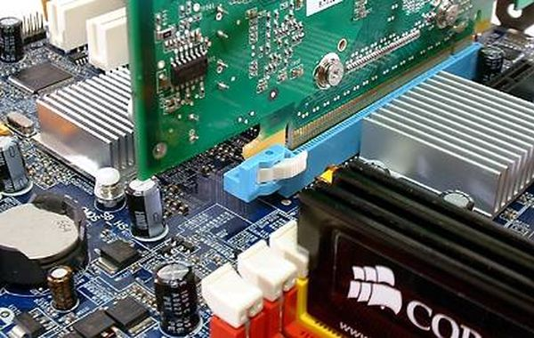
Simply, we have to insert the card in a compatible slot. It's very important to insert them making an axial force, that is, as vertical as possible You have to insert it softly and being careful, otherwise you can damage the motherboard or the card.

Assembling a computer. Step 5 – Connecting Hard disk, DVD and other SATA components
In this step, we are going to connect SATA components (usually hard disk or DVD) to the motherboard. Firstly, we have to screw the component to an available bay that fits with its size. Remember that only 3 screws required.
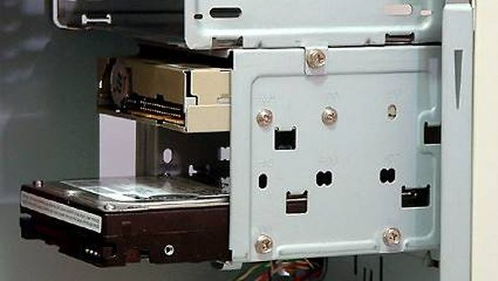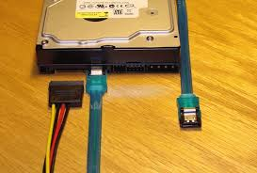
Secondly, we have to connect it to the power supply. And finally, we have to connect the component to the motherboard using a SATA bus.

Assembling a computer. Step 6 – Closing the case and connecting external peripherals
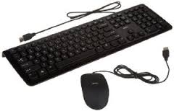
In this final step, we will close the case with all the internal components working and connect the external peripherals. Most common peripherals are:
- Keyboard / mouse: they are usually connected by USB ports.
- Monitor: it is connected by VGA, DVI or HDMI port.
- Speakers: they are connected to sound ports.
- Network: usually it is an RJ-45 connector.

Bibliography
[1] Visual guides and video tutorials provided.

